CSI473 PHASE 1 DRAFT
Tsa Temo Thuo
A Farm Produce Ordering and Delivery Coordination System for Botswana's Horticulture Sector
Course | CSI473 · Semester 1, 2026/27
Team number | 10
Phase | Phase 1 Interaction, lifecycle and integrated draft
Core use case | UC-01 Place Order
Project scope | Produce listing → ordering → reservation → confirmation → delivery
Prepared for | Phase 1 / Lab 5 integration and review
Lecturer | Dr Cleverence Kombe

Team members
Name | Student ID
Obvious Njembu | 201801639
Stacey Batshanani Nthoi | 202004071
Thatayaone Mogale | 201802565
Ellen Laone Olefile | 201800730
Document basis
This Phase 1 draft uses the approved Tsa Temo Thuo project proposal as its project baseline.

1. Project overview and approved problem
Tsa Temo Thuo is a farm produce ordering and delivery coordination system for Botswana's horticulture sector. The approved project problem identifies a gap between available locally grown produce and reliable access to buyers. Farmers may rely on informal channels, while smaller buyers can have limited visibility of what is available, where it is located and at what price. Separate transport arrangements can add further coordination delays for perishable produce.

1.1 Project goal
The approved goal is to improve market access and reduce avoidable post-harvest losses in Botswana's horticulture value chain by digitally coordinating produce listing, ordering and delivery between verified farmers, buyers and transport providers.

1.2 Project objectives
- By Phase 2, a verified farmer can publish a produce listing and a buyer can place an order that the farmer confirms and a transporter delivers end-to-end using synthetic data and automated success-path tests.
- The system guarantees stock integrity so confirmed order quantities never exceed a listing's available quantity, including under concurrent or duplicate order attempts.
- A buyer can locate available produce filtered by crop and district and complete order placement in five or fewer screens, while an administrator can generate an order-status report from live system data.

1.3 Approved scope
- Farmer and buyer registration with administrator verification using simulated documents.
- Produce listings containing crop, grade, unit price, available quantity, district and availability window.
- Listing lifecycle: Active / Sold Out / Expired.
- Order placement and lifecycle management: Placed → Confirmed → Assigned → In Transit → Delivered.
- Atomic stock reservation with explicit Declined, Cancelled and Reservation Expired release rules.
- Transport request and assignment for confirmed orders, plus basic administrative order-status reporting.

1.4 Out-of-scope functionality
- Digital payments, escrow and financial settlement.
- Warehouse booking and storage management.
- AI recommendations, weather/statistics integrations, predictive analytics and crop-disease reporting.
- Livestock trading, financing and extension-officer services.
- Live third-party integrations; notifications and maps remain stubbed.

2. Stakeholders and system boundary
Stakeholder | Need | Key concern
Smallholder horticulture farmer | Reliable buyers before produce deteriorates; visibility of demand and fair pricing | Digital literacy, data costs and trust
Buyer; restaurant, small retailer or street trader | Consistent local supply and transparent availability, location and price | Produce quality/grading and fulfilment reliability
Transport provider | Well-specified delivery jobs with pickup/drop-off details | Cancellations after commitment and spoilage responsibility
Platform administrator | Verify users, monitor activity and produce reports | Fraudulent/duplicate listings and dispute workload
Ministry of Agriculture / Botswana Horticulture Council | Sector-level visibility and evidence of local market access | Data accuracy and protection of farmer information

For the Phase 1 core interaction, the Buyer initiates UC-01. The Farmer is the owner of the selected Listing and later decides whether the Placed Order is confirmed or declined. The Transporter becomes relevant after confirmation. The platform administrator provides verification and reporting functions outside the immediate order-placement interaction.

3. Requirements baseline and traceability
The Phase 1 design concentrates on the approved requirements that directly support the vertical slice and UC-01. The models also preserve the relationship to transport, history and reporting so that the interaction is not treated as an isolated transaction.
Requirement | Approved focus | Phase 1 evidence
FR-05 | Verified buyer places an order against an Active listing | UC-01 + sequence/activity models
FR-06 | Atomic reservation and no overselling under concurrency/duplicates | Sequence guard + stock invariant + AC-04/AC-05
FR-07 | Reject invalid quantity or unavailable listing without changing stock | Alternative flows + activity decisions
FR-08 | Farmer confirms or declines a Placed order | Order lifecycle
FR-09 | Listing becomes Sold Out or Expired under its lifecycle rules | Listing/order interaction
FR-10–FR-11 | Transport assignment and delivery progression | Lifecycle continuation
FR-12 | Current order state and full status history visible | OrderStatusEvent/audit rationale
FR-13 | Administrator order-status reporting | Persisted lifecycle/history data

4. UC-01 — Place Order
UC-01 allows a verified Buyer to place an order for a selected quantity of produce against an Active listing. The core purpose is to reserve the requested quantity safely and produce a persistent order record that can continue through farmer confirmation and delivery.

4.1 Preconditions
- The Buyer is registered and verified.
- The selected Listing is Active and within its availability window.
- The Listing has sufficient remaining unreserved quantity.
- The buyer has selected a valid positive quantity.

4.2 Main success scenario
- Buyer searches Active listings and selects a suitable listing.
- Buyer reviews crop, grade, unit price, district, availability window and remaining quantity.
- Buyer enters the desired quantity and submits the order with a client-generated idempotency token.
- System checks the token and prevents duplicate processing if the request has already been accepted.
- System verifies that the listing remains Active and validates the requested quantity against current remaining stock.
- System performs an atomic stock reservation.
- System creates the Order in Placed state and persists the buyer/listing relationship and timestamp.
- System appends the Placed status event for history/audit purposes.
- If the reservation consumes all remaining unreserved stock, the Listing becomes Sold Out.
- System notifies the Farmer and returns a Placed confirmation to the Buyer.

4.3 Alternative and exception flows
Quantity exceeds availability: Reject the request, create no valid reservation, and return the actual maximum available quantity.
Listing is Sold Out or Expired: Reject without changing stock.
Concurrent requests compete for the last stock: The atomic reservation determines the winner; losing requests are controlledly rejected.
Buyer retries after poor connectivity: The same idempotency token returns the existing Order rather than creating another reservation.
Farmer declines: The order becomes Declined and the full reservation is released exactly once.
Buyer cancellation: Where permitted, the Placed order becomes Cancelled and its reservation is released.
Reservation expires: The order becomes Reservation Expired and its reservation is released, subject to the listing availability window.

4.4 Acceptance-criteria alignment
- AC-01: 50 kg remaining and 20 kg ordered → order becomes Placed and 30 kg remains.
- AC-02: 15 kg requested against 10 kg remaining → reject, create no Order and report 10 kg as the maximum.
- AC-03: Sold Out or Expired listing → reject with no reservation.
- AC-04: two simultaneous 5 kg requests against 5 kg remaining → exactly one reservation succeeds and the listing becomes Sold Out.
- AC-05: retry with the same idempotency token → return the original Order without a second reservation.

5. Business rules and stock integrity
Stock integrity is the highest-risk business rule in the core workflow. The approved proposal explicitly requires the system to handle concurrent and duplicate order attempts without overselling.
Stock invariant
Available + Reserved + Confirmed = Total
Reserved + Confirmed ≤ Total

- A successful order moves quantity from Available to Reserved exactly once.
- Farmer confirmation transfers Reserved to Confirmed; it does not deduct Available a second time.
- A decline, cancellation or reservation expiry returns the reserved quantity to Available exactly once.
- If a decline makes stock available again and the availability window has not expired, a previously Sold Out listing may return to Active.
- Expired reservations cannot be reused after the listing availability window has ended.
- Only the listing's farmer may confirm or decline the relevant order.

6. Interaction / sequence model
The sequence model assigns orchestration to the Tsa Temo Thuo System while preserving domain responsibilities: Listing controls atomic reservation, Order owns lifecycle state, OrderStatusEvent records history and the SMS Gateway handles notification as a stubbed external dependency.
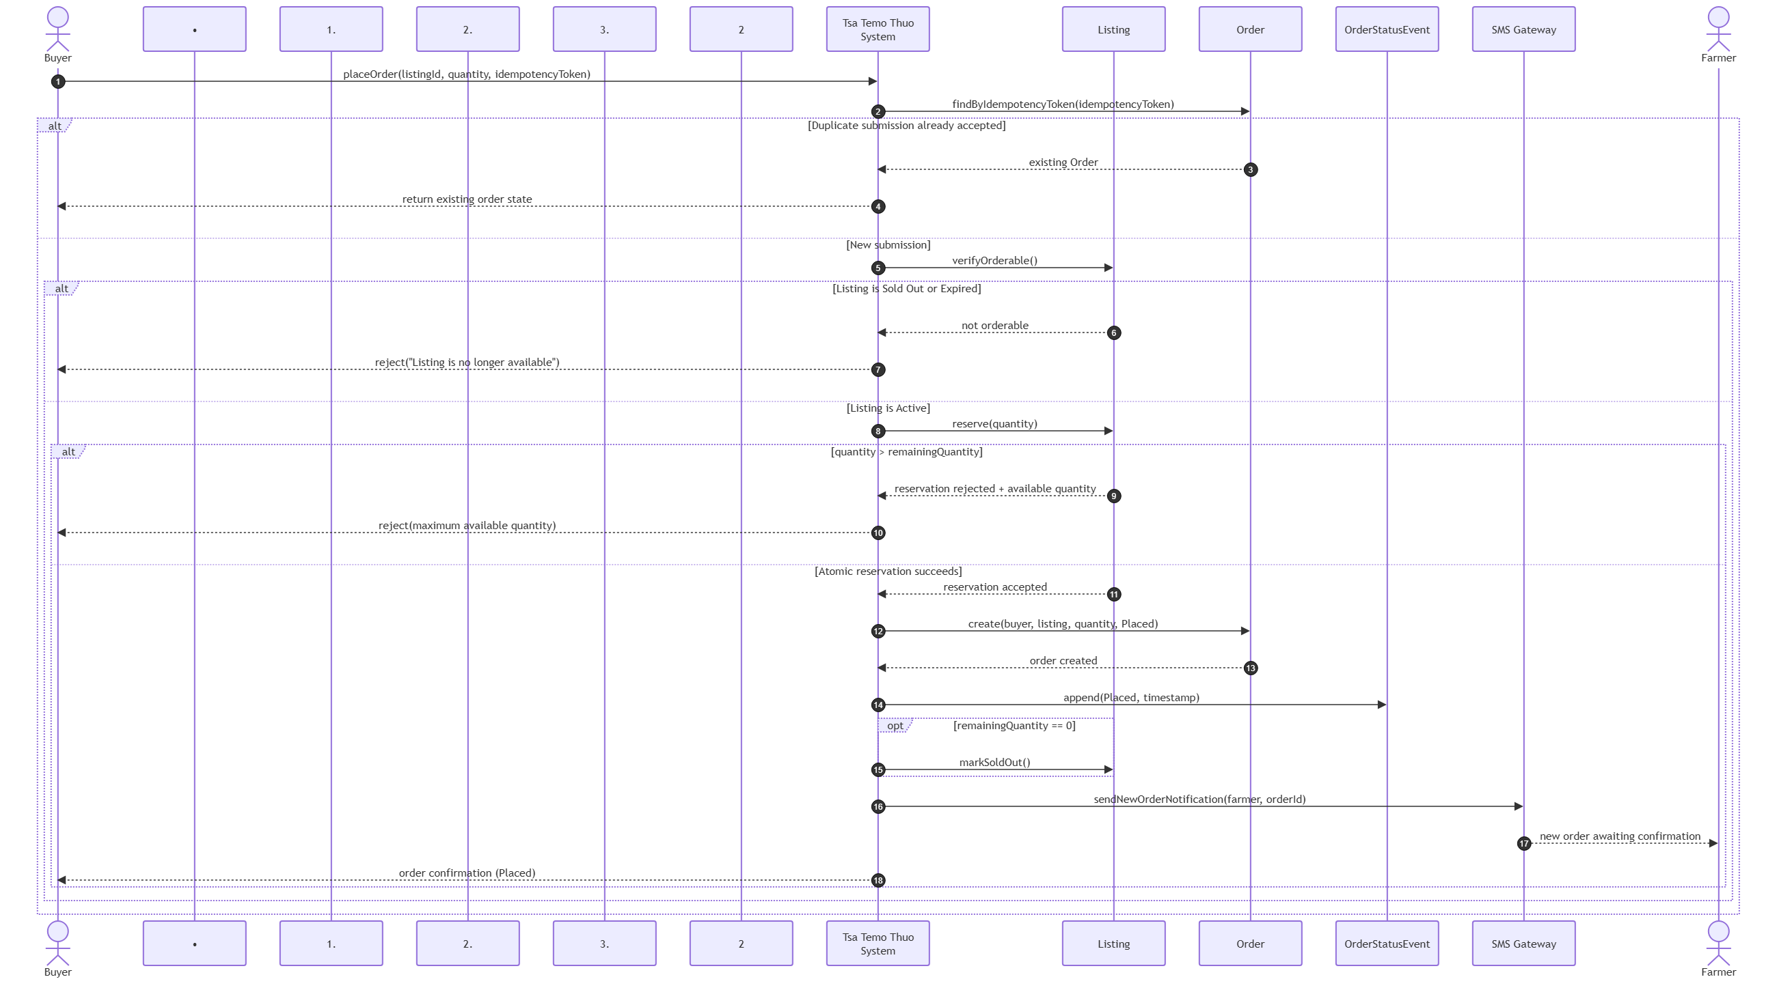
Figure 1.

6.1 Design rationale
The key design choice is to make stock reservation atomic rather than performing a simple read-then-write quantity check. This is necessary because two buyers can observe the same remaining stock at nearly the same time. The atomic operation creates a clear consistency boundary and directly supports the zero-oversell objective.
A simpler alternative would create the Order first and reserve stock afterwards. That alternative was rejected because a failure between those operations could leave an Order without valid stock backing and would make rollback and duplicate handling harder.

7. Order lifecycle and workflow
The Order is the selected state-sensitive entity for Lab 5. Its main lifecycle is Placed → Confirmed → Assigned → In Transit → Delivered, with explicit terminal/exception paths for Declined, Cancelled and Reservation Expired.
State/transition | Actor | Consequence
Placed | Buyer / System | Created only after successful atomic reservation.
Confirmed | Farmer | Reserved stock transfers to Confirmed without a second deduction.
Declined | Farmer | Reservation released to Available.
Cancelled | Buyer, where authorised | Reservation released to Available.
Reservation Expired | System | Reservation released, subject to listing availability window.
Assigned | Transporter | Confirmed order receives an accepted transport assignment.
In Transit | Transporter | Delivery is underway.
Delivered | Transporter / Buyer | Delivery completed and receipt can be confirmed.

8. Activity model
The activity model shows the same UC-01 logic from a workflow perspective, making the major decision points visible: duplicate detection, listing availability, quantity validation, atomic reservation and the Sold Out consequence.
- Duplicate token → return existing order.
- Listing not Active → reject without reservation.
- Quantity invalid or too large → reject and show actual availability.
- Atomic reservation fails because another buyer won the stock → controlled rejection.
- Remaining quantity reaches zero → listing becomes Sold Out.

9. Consistency matrix
The matrix below links the use case, interaction responsibilities, lifecycle state/result and approved requirement/acceptance evidence. This prevents the diagrams from describing different versions of the project.
UC/rule | Action/message | Responsibility | State/result | Trace
Step 3 | Submit quantity + token | Buyer → System | Request received | FR-05; AC-01
Duplicate retry | Find existing token | System → Order | Existing Order returned | FR-06; AC-05
Step 4 | Verify listing + quantity | System → Listing | Active / rejected | FR-07; AC-02–03
Step 5 | Atomic reserve | System → Listing | Reserved increases | FR-06; AC-04
Step 6 | Create order | System → Order | Placed | FR-05; AC-01
Step 7 | Persist event/timestamp | System / Event | History updated | FR-12
Step 8 | Notify farmer | System → SMS → Farmer | Farmer notified | UC-01
Last stock | Mark Sold Out | System → Listing | Sold Out | FR-09; AC-04
Farmer decline | Release reservation | Farmer → System | Declined | FR-08
Buyer cancellation | Release reservation | Buyer → System | Cancelled | UC-01
Timeout | Release reservation | System | Reservation Expired | UC-01
Confirmation | Transfer Reserved → Confirmed | Farmer → System | Confirmed | FR-08
Delivery | Assign → In Transit → Delivered | Transporter → System | Delivery lifecycle | FR-10–FR-11

10. Quality concerns and design trade-offs

10.1 Concurrency and data integrity
Two buyers competing for the final stock are a critical failure scenario. The system must guarantee that accepted quantities do not exceed the listing quantity. Database-level atomicity/constraints and automated concurrency tests are therefore part of the design evidence.

10.2 Poor connectivity and duplicate submission
The approved problem assumes intermittent internet connectivity. A client-generated idempotency token allows a retry to be recognised as the same request, reducing duplicate orders while still giving the Buyer a clear result.

10.3 Usability versus information richness
The proposal recognises the need to support users with potentially low digital literacy and rural connectivity. The Buyer workflow should therefore expose only the information necessary for a confident order while meeting the objective of completing placement in five or fewer screens.

10.4 Privacy and transparency
Only synthetic names, IDs, contacts and coordinates are used in development and demonstration. This limits privacy exposure while still allowing the workflows to be tested realistically.

10.5 Produce-quality responsibility
The farmer is responsible for the accuracy of produce description and declared grade/quality at listing and for the condition at handover. The transporter is responsible for reasonable care in transit, while the buyer checks produce at receipt and may record a discrepancy. Tsa Temo Thuo records the relevant information but does not independently certify produce quality.

11. Lab 5 contradiction and revision record
The main contradiction identified during integration was that the initial lifecycle representation did not make all UC-01 release paths visible. The approved proposal explicitly includes Declined, Cancelled and Reservation Expired rules. The Phase 1 lifecycle therefore includes these paths and associates each with release of the reserved quantity.
A second consistency issue was responsibility clarity in the interaction model. The refined sequence distinguishes the system, Listing, Order, OrderStatusEvent, SMS Gateway and human actors so that each message can be traced to a clear responsibility.

12. Open issues and final Phase 1 checklist
- Confirm the configurable reservation-expiry duration.
- Confirm the final reporting treatment for Declined, Cancelled and Reservation Expired orders.
- Confirm the team's final editable modelling-tool format.
- Keep editable sources and readable exports in the shared repository; screenshots alone are not source evidence.
- Commit the revised artefacts with a meaningful Git commit and retain visible evidence of revision after critique.

Appendix A Team and project identification
Repository: github.com/Shawnjembu/Tsa-Temo-Thuo
Phase 1 draft submitted:04 September 2026

Appendix B Model evidence

Figure B. Sequence diagram

